**Dorm Management System**

Although we’ve now come to love Tofu and have adapted to the vegetarian/vegan life, we wouldn’t want to forget how meat tastes like, so we sometimes find ourselves cooking in the dorm kitchen. However, the current kitchen key system could use an improvement because sometimes we don’t know who is currently holding the key and we’d have to wait for them to respond to the group chat. To address this real-life concern, we decided to create a management system and expand the scope to help us manage not just the kitchen key but the rooms as well.

For this system, we identified 2 main actors, the Students, and the Admins. The students can borrow the kitchen key, check who is currently borrowing the kitchen key, report lost keys, create issue reports(if anything is wrong with our dorm rooms), and file change room requests. The Admin on the other hand, can add the kitchen keys to the system, check for available rooms, create room assignments, address issue reports, cater to change room requests, generate kitchen key usage reports, and generate room assignment reports.

Through this system, we can promote accountability and ease of tracking when it comes to kitchen key usage. We could also efficiently track if there are issues or concerns being raised in any of the rooms in the dormitory so that they can be addressed the soonest time possible.

**Kitchen Key Module – Use Case Diagram**

**

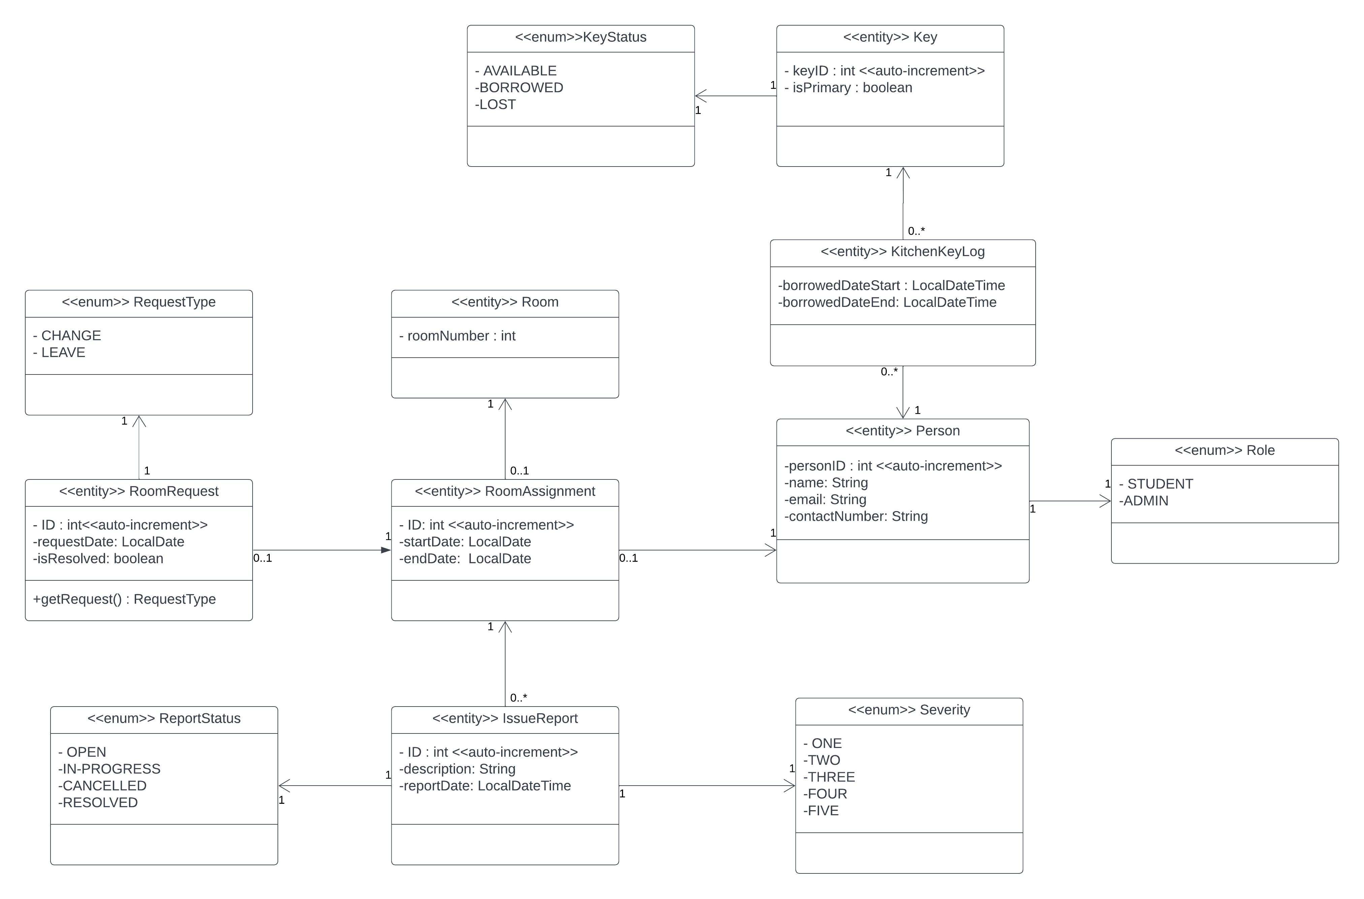**Dorm Management System – Class Diagram**